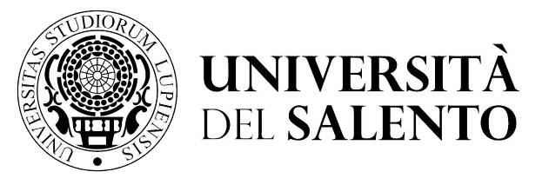 | Ripartizione didattica e servizi agli studenti  AREA POST LAUREA  Ufficio master e dottorati  master.dottorati@unisalento.it | Centro Congressi  Campus Ecotekne  S.P. 6, Lecce- Monteroni  Tel. +39 832 – 9210 -9232-9238 - 9041
Allegato (Annex) 2)

SUBJECT: Request to cancel the application submitted by ____________ for the PhD in “…….....................................................” – 36th cycle.

To the person responsible for the admissions procedure

The undersigned, born at ________________, resident in ___________, tel. ___________, email ______________, having applied to participate in the competitive selection procedure for admission to the PhD Course in ___________________________, approved by D.R (rector’s decree) and needing to replace documents what has been stated or attached

REQUESTS

that he or she is allowed to cancel the application, in accordance with the provisions of article 5 of the call for applications for the competitive selection procedure and in the manner specified therein, the application to participate in the competitive selection procedure in question already completed online.

Date Signature

N.B. A valid identity document must be attached to this form, to be completed according to the terms of article 5 of the call for applications for the competitive selection procedure.
This form must be sent to the registered email (PEC) address of the amministrazione.centrale@cert-unile.it within the deadline of the call for applications.

